Dependenci injection lifetime

Có 3 kiểu DI container khai báo trong program.cs

AddTransient

AddScoped

AddSingleton

AddTransient luôn trả về giá trị mới

AddScoped chia sẻ giá trị trong 1 request , gửi request mới thì sẽ nhận được giá trị khác

AddSingleton chỉ tạo ra 1 lần và chia sẻ nếu id đó được gọi

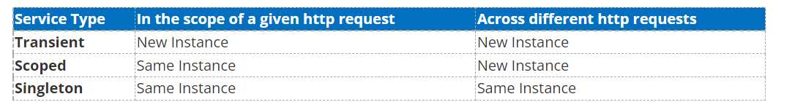

<https://www.c-sharpcorner.com/article/understanding-addtransient-vs-addscoped-vs-addsingleton-in-asp-net-core/>